Computer Hacking and Digital Forensics Investigator (CHFI)
Project SME: Sandeep Jhangir
Course: Cyber Security / Digital Forensics
Total Marks: 50
Student Name: Chougle Talha Zahoor Ahmed
Instructor Name: Sandeep Jhangir
Submission Date: 20th March 2026

Section A – File Integrity (10 Marks)
Question 1 (10 Marks)
File Selected
For this task, a text file named testfile.txt was selected from the Desktop of the Windows system. The file was created using Notepad and contains sample text data.

The hash values were calculated using HashCalc, a free forensic hashing tool. The following values were obtained:
Algorithm | Hash Value
MD5 | 5c7cda38025a6f4f6d33abd0a73e6cb8
SHA1 | 7fef107f5206e0c7ebef2dd6009fd75246ff382f
SHA256 | d313ae9b930f587598b3ddde94d0ccb85664eacf47bc3d98a540a9c63c2dfea1

Why hashing is important in digital forensics?
Hashing plays a vital role in digital forensics as it produces a unique fixed value for any file. This value acts as a digital fingerprint — if the file is modified even slightly, the hash value changes completely. During an investigation, forensic experts calculate the hash of evidence at the time of collection and again after analysis. If both values match, it confirms the evidence was not altered, making it valid and admissible in a court of law. Tools like HashCalc make this process simple and reliable.
Screenshot
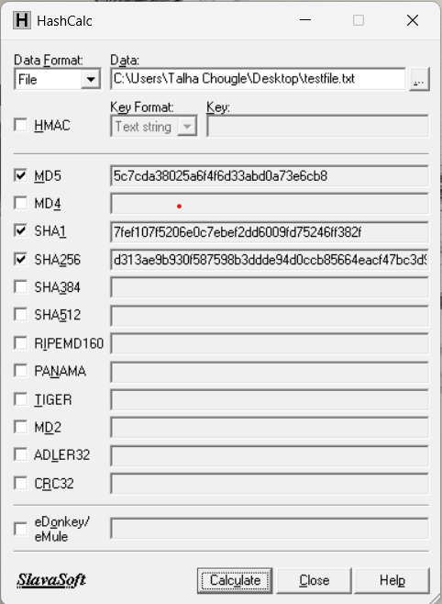
Figure A - 1: HashCalc showing MD5, SHA1 and SHA256 hash values of testfile.txt

Section B – Hashing on Mobile or Disk (10 Marks)
Question 2 (10 Marks)
Hashing on a mobile device or disk storage is a fundamental process in digital forensics. When a storage device such as a hard drive, USB drive, SD card, or mobile device is collected as evidence, investigators create a forensic image of the device — which is an exact bit-for-bit copy of the entire storage. This image is then hashed using a forensic tool to generate a unique digital fingerprint of the device's contents.
The hash value is recorded at the time of acquisition and again after analysis. If both values match, it confirms that the forensic image is identical to the original device and that no data was added, removed, or modified during the investigation. This process is critical because it ensures the integrity of digital evidence and makes it legally admissible in court.

Name of the tool used
The tool used for this task was HashCalc, a free and lightweight forensic hashing utility developed by SlavaSoft. It supports multiple hashing algorithms including MD5, SHA1, and SHA256, making it a reliable tool for verifying the integrity of disk images and storage media.

Step-by-step explanation of the hashing process
To perform hashing on a disk storage, a disk image file named testdisk.img was created on the Windows system. A disk image is a complete copy of a storage device saved as a single file, which is exactly how forensic investigators work — they never hash the original device directly, they always work on an image to preserve the original evidence.
The following steps were performed:
- HashCalc was launched on the Windows system.
- The Data Format dropdown was set to File to allow selection of a disk image file.
- The disk image file testdisk.img was selected using the browse button.
- The hashing algorithms MD5, SHA1, and SHA256 were selected by ticking their checkboxes.
- The Calculate button was clicked to begin the hashing process.
- HashCalc instantly computed and displayed the hash values for all three algorithms as shown in the table and screenshot below.

Table & Screenshot
Algorithm | Hash Value
MD5 | f1c9645dbc14efddc7d8a322685f26eb
SHA1 | 8c206a1a87599f532ce68675536f0b1546900d7a
SHA256 | e5b844cc57f57094ea4585e235f36c78c1cd222262bb89d53c94dcb4d6b3e55d

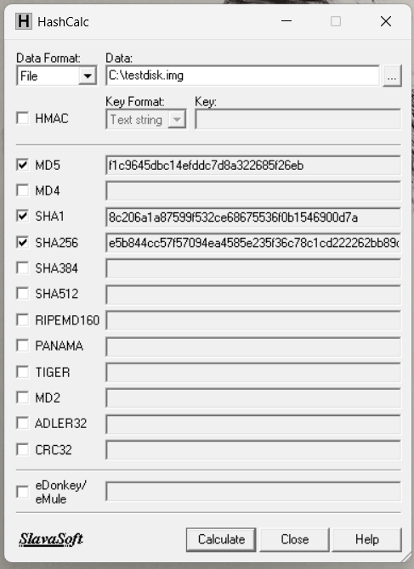
Figure B - 1: HashCalc showing hash values of testdisk.img disk image file

Section C – Chain of Custody (10 Marks)
Question 3 (10 Marks)
Answer the following:
1. What is Chain of Custody in digital forensics?
Chain of Custody is a documented record that tracks every person who has handled a piece of digital evidence from the moment it was collected until it is presented in court. It includes details such as who collected the evidence, when it was collected, where it was stored, and who accessed it at each stage. The purpose of maintaining a chain of custody is to prove that the evidence is authentic and has not been altered or tampered with at any point during the investigation.

2. Why is Chain of Custody important in cybercrime investigations?
Chain of Custody is extremely important in cybercrime investigations because digital evidence is very easy to modify or delete. If there is no proper record of how the evidence was handled, the defense can argue that the evidence was tampered with and get it dismissed in court. A proper chain of custody ensures that the evidence is trustworthy, legally admissible, and that every person who touched it is accountable for their actions.

3. What information should be recorded in a Chain of Custody document?
The following information should be recorded in a Chain of Custody document:
- Case number and evidence item number
- Description of the evidence such as device type, brand, and serial number
- Date, time, and location where the evidence was collected
- Name of the person who collected the evidence
- Hash values of the evidence taken at the time of collection
- Storage location of the evidence
- Details of every transfer including who sent it, who received it, and when
- Names of everyone who accessed the evidence and when
- Physical condition of the device at the time of seizure

Section D – RAM Capture (10 Marks)
Question 4 (10 Marks)
RAM (Random Access Memory) capture is the process of extracting the contents of a computer's live memory at a specific point in time. Since RAM is volatile, meaning its data is permanently lost when the system is powered off, it must be captured immediately during a live investigation before the system is shut down.

Tools used for RAM capture
The tool used for RAM capture in this task was DumpIt, a free and portable memory acquisition tool. It is a single executable file that requires no installation and can be run directly from a USB drive or any folder on the system. DumpIt captures the entire contents of physical RAM and saves it as a raw memory dump file.

Step-by-step explanation of the RAM acquisition process
- DumpIt.exe was downloaded and placed in a folder named Dump on the Desktop.
- DumpIt.exe was right-clicked and launched as Administrator.
- A confirmation prompt appeared asking to proceed — Y was pressed and Enter was hit to begin the capture.
- DumpIt automatically captured the entire RAM and saved it as a .raw file in the same folder.
- Once the capture was complete, PowerShell was opened as Administrator and the following command was run to generate a SHA256 hash of the dump file to verify its integrity:
Get-FileHash -Path "C:\Users\Talha Chougle\Desktop\Dump\LAPTOP-03K7BGGD-20260320-130845.raw" -Algorithm SHA256

- The hash value was recorded as proof that the RAM dump was not tampered with.

Importance of RAM capture in digital investigations
RAM capture is one of the most critical steps in a live forensic investigation for the following reasons:
- RAM contains volatile data such as running processes, open network connections, encryption keys, and login credentials that disappear the moment the system is turned off.
- Many modern malware programs run entirely in memory and leave no trace on the hard drive — RAM capture is the only way to detect them.
- If a suspect is using encryption software, the decryption keys may be stored in RAM while the system is running, which can only be recovered through memory acquisition.
- Capturing and hashing the RAM dump ensures the integrity of the volatile evidence collected.

Screenshot
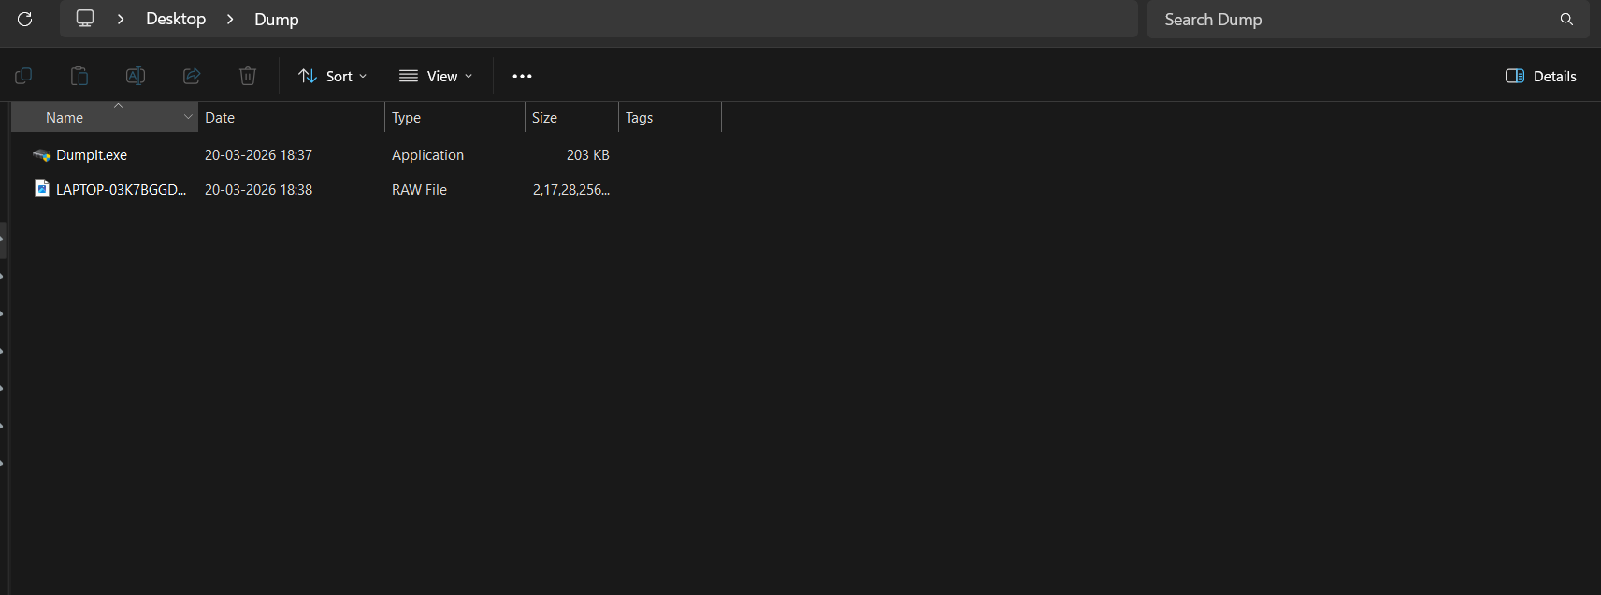
Figure D - 1: Dump folder showing DumpIt.exe and the captured RAM dump file

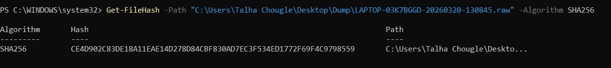
Figure D - 2: SHA256 hash of the RAM dump file generated using PowerShell

Section E – Network Capture using Wireshark (10 Marks)
Question 5 (10 Marks)
Wireshark is a free and open-source network protocol analyzer used to capture and analyze network traffic in real time. In this task, Wireshark was used to perform a live packet capture on a Windows system connected to a Wi-Fi network. The captured traffic was then analyzed to identify packets related to Google, observe the DNS resolution process, and understand the different types of network traffic based on Wireshark's color coding system.

Steps to start packet capture in Wireshark
Wireshark was launched as Administrator on the Windows system. On the main screen, all available network interfaces were displayed along with their live activity graphs. The active interface Wi-Fi was identified by its moving graph and double-clicked to begin the capture. Wireshark immediately started capturing all network packets passing through the interface, displaying them in real time with color coding based on their protocol type.

Visit google.com during the capture process
While Wireshark was actively capturing packets, a web browser was opened and http://google.com was visited. The page was allowed to fully load before returning to Wireshark. The capture was then stopped by clicking the red square Stop button in the toolbar. The capture file was saved as google_capture.pcapng on the Desktop.

Identify packets related to Google traffic
To identify packets related to Google traffic, the following display filter was applied in the Wireshark filter bar:
dns.qry.name contains "google"
This filtered the packet list to show only DNS packets related to Google. The results clearly showed multiple DNS query and response packets for www.google.com, with Google's IP address 142.250.70.100 visible in the responses. This confirms that the system successfully communicated with Google's servers during the capture.

Wireshark color codes and their meanings
Color | Protocol / Event | Meaning
Light Green | TCP Traffic | Standard TCP connection packets
Light Blue | UDP / DNS | UDP packets and DNS queries
Dark Black | TCP Errors | TCP checksum errors or corruption
Light Yellow | ARP / ICMP | Address Resolution and ping packets
Dark Red | HTTP | Unencrypted HTTP web traffic
Purple | TCP Retransmission | Retransmitted TCP segments
Red/Pink | Errors | Malformed packets or connection resets
Dark Gray | Bad TCP | Duplicate ACKs or out-of-order packets
Light Gray | SMB / NBNS | Windows file sharing traffic

Screenshot
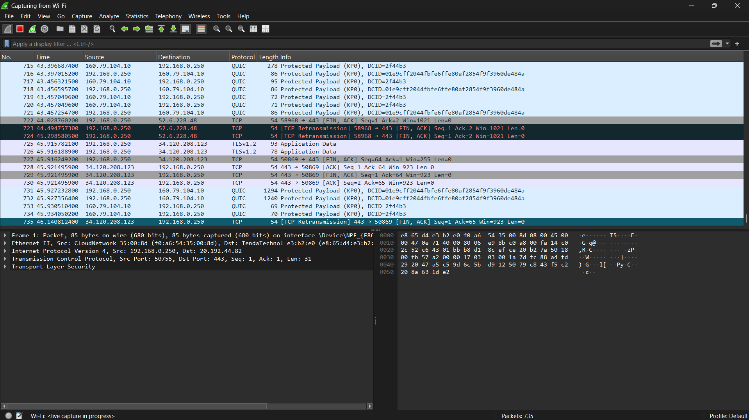
Figure E - 1: Wireshark capturing live network traffic on Wi-Fi interface
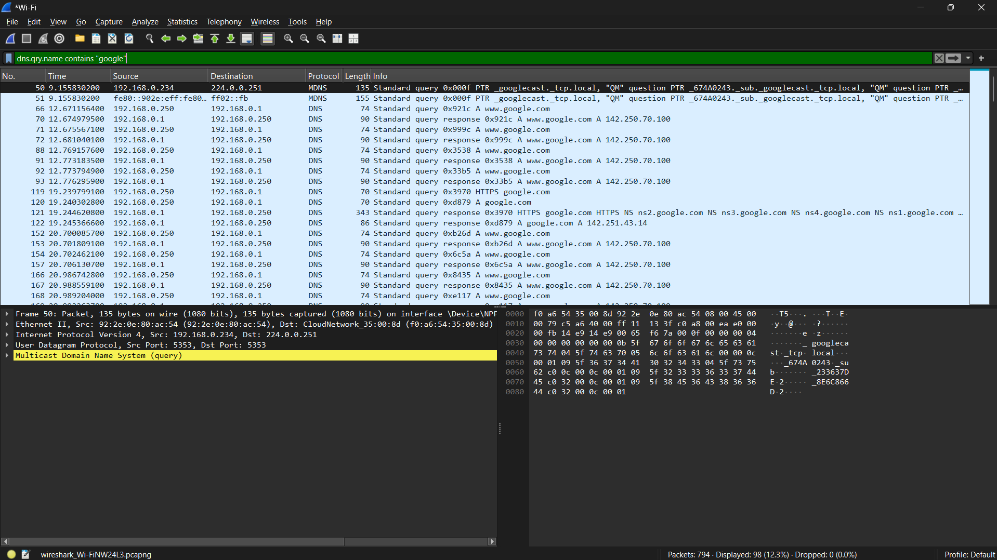
Figure E - 2: Wireshark DNS filter showing google.com related packets

